PMT Controller

Vault Folder: PMT Controller

Nathan Clack

Research Specialist

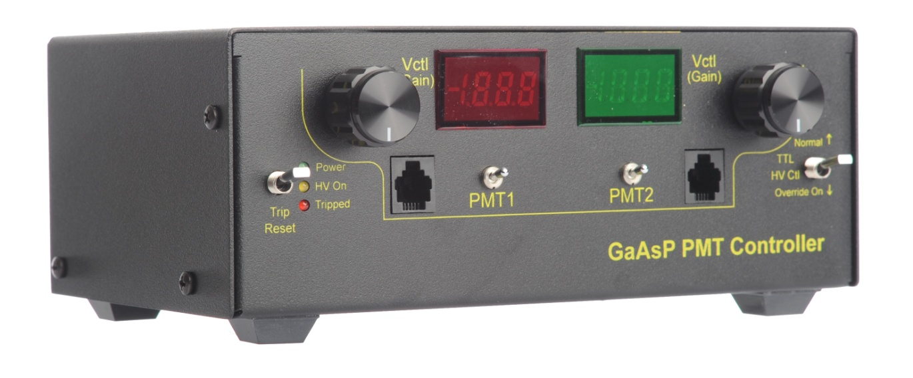

Steve Sawtelle  
Electrical Engineer, ID&F  
(571) 209-4158

Contents

System Overview 2

Hardware Development 2

Assembly, Test, and Calibration 7

# System Overview

The PMT Controller provides two channels of control for GaAsP Photo Multiplier Tubes. The low –noise design uses static logic, linear power supplies, and an AC line filters. The control voltages are independently adjustable over their entire range via a multi-turn controls, with the voltages displayed on the built-in meters. Each PMT can be switched on and off independently. A trip circuit is built-in to detect high PMT currents. Trip level and duration can be independently set for each channel. A trip condition turns off both PMTs and can be reset via a front panel control. External control of high voltage and trip reset are also provided.

# Hardware Development

The PMT Controller is based off a previous Janelia design. Care was taken to eliminate switching noise. Only the panel meters use switching electronics.

The trip detect circuits have some high frequency noise filters (~30kHz), followed by a level comparator with adjustable threshold. This is followed by an adjustable trip delay circuit. Therefor a trip detect occurs when the input signal reaches a particular threshold and lasts a certain duration. The two trip signals are OR’ed together to create single trip event if either input satisfies the trip requirements. This in turn sets a latch to turn off the high voltage control and a trip indicator LED. The trip condition can be reset using the Trip Reset switch.

Each channel can be turned on and off independently. There is a common high voltage control.

*Schematic*

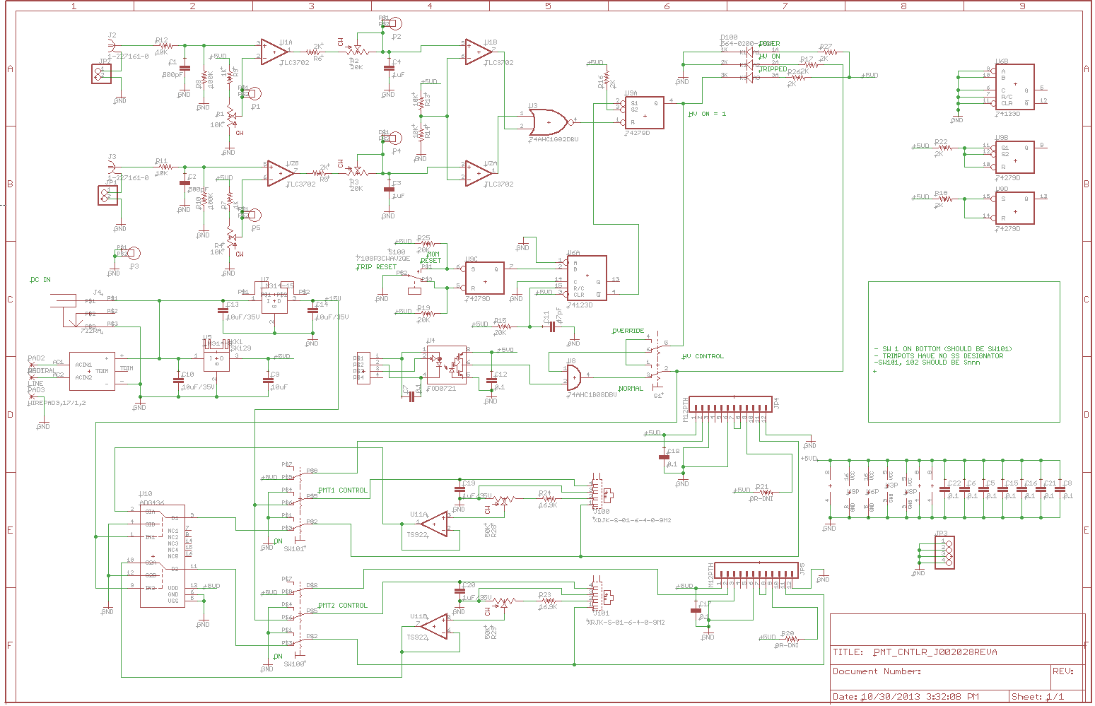

*Printed Circuit Board*

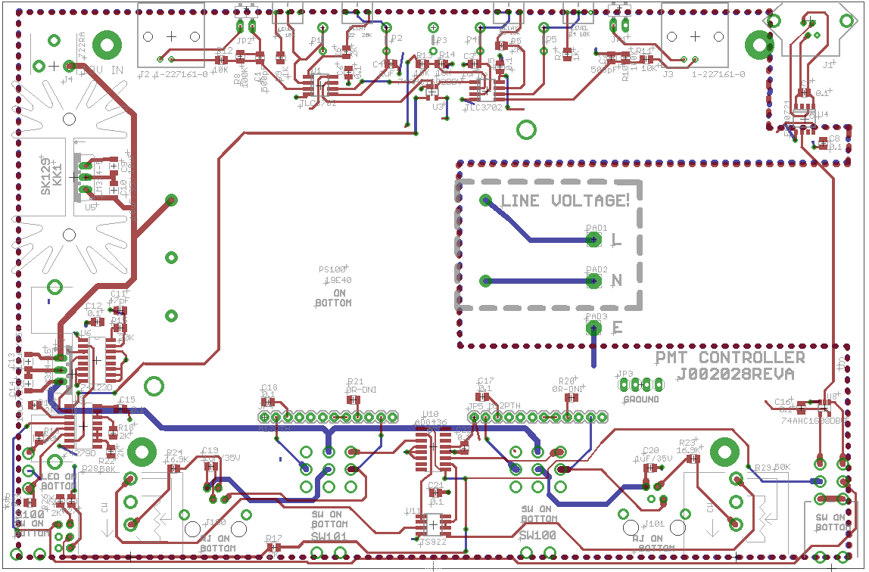

*Materials*

|  |  |  |  |  |  |  |
| --- | --- | --- | --- | --- | --- | --- |
| **Qty** | **Value** | **Device** | **Manufacturer** | **Manuafcturer PN** | **Digi-Key PN** | **Designators** |
| 1 | 66010-004LF | RJ9 4P4C | FCI | 66010-004LF | 609-3785-ND | J1 |
| 2 |  | HEADER 1X2 M RA | Molex | 22-12-2021 | WM2733-ND | JP1 JP2 |
| 1 |  | HEADER 1X4 M ST | TE Connectivity | 3-644456-4 | A31114-ND | JP3 |
| 2 |  | SWITCH-3PDT-VERT3PDT_VERT_RA | NKK | M2032S2A2W40 | 360-2858-ND | SW100 SW101 |
| 1 |  | SWITCH-DPDT ON-NONE-ON | C&K | 7201P3CWAV2SE | CKN9728-ND | S1 |
| 1 |  | SWITCH-SPDT ON-NONE-MOM | C&K | 7108P3CWAV2QE | CKN9716-ND | S100 |
| 5 |  | TEST POINT | Keystone | 1045 | 1045K-ND | P1 P2 P3 P4 P5 |
| 11 | 0.1 | CAPS0805S | KEMET | C0805C104K1RACTU | 399-3486-1-ND | C5 C6 C7 C8 C12 C15 C16 C17 C18 C21 C22 |
| 2 | 0R-DNI | RESISTOR_SM0805S | DNI | DNI | DNI | R20 R21 |
| 2 | 5227161-9 | BNC, PCB , RA, LOW | TE Connectivity | 5227161-9 | A32261-ND | J2 J3 |
| 2 | 1K | RESISTOR_SM0805S | VISHAY | CRCW08051K00FKEA | 541-1.00KCCT-ND | R7 R9 |
| 2 | 1uF | CAPS0805S | Kemet | C0805C105KRACTU | 399-7409-1-ND | C3 C4 |
| 2 | 1uF/35V | CAPS0805S | MURATA | GRM31CR61H106KA12L | 490-5961-1-ND | C19 C20 |
| 8 | 2K | RESISTOR_SM0805S | VISHAY | CRCW08052K00FKEA | 541-2.00KCCT-ND | R5 R6 R16 R17 R18 R22 R26 R27 |
| 2 | 10K | POT3362M | Bourns | 3362M-1-103LF | 3362M-103LF-ND | R1 R4 |
| 4 | 10K | RESISTOR_SM0805S | VISHAY | CRCW080510K0FKEA | 541-10.0KCCT-ND | R11 R12 R13 R14 |
| 4 | 10uF/35V | CAPS1206S | TAIYO YUDEN | GMK316AB7106KL-TR | 587-3007-1-ND | C9 C10 C13 C14 |
| 2 | 16.9K | RESISTOR_SM0805S | VISHAY | CRCW080516K9FKEA | 541-16.9KCCT-ND | R23 R24 |
| 1 | 19E40 | ACOPIAN_PS | Acopian | 19E40 | from manufacturer | PS100 |
| 2 | 20K | POT3362M | Bourns | 3362M-1-203LF | 3362M-203LF-ND | R2 R3 |
| 3 | 20K | RESISTOR_SM0805S | VISHAY | CRCW080520K0FKEA | 541-20.0KCCT-ND | R15 R19 R25 |
| 1 | 47pF | CAPS0805S | JOHANSON | 500R15N470JV4T | 709-1175-1-ND | C11 |
| 2 | 50K | POT | Bourns | 3590P-4-503L | 3590P-4-503L-ND | R28 R29 |
| 1 | 74AHC1G02DBV | 74AHC1G02DBV | TI | SN74AHC1G02DBVR | 296-1088-1-nd | U3 |
| 1 | 74AHC1G08DBV | 74AHC1G08DBV | TI | SN74AHC1G08DBVR | 296-1091-1-ND | U8 |
| 2 | 100K | RESISTOR_SM0805S | VISHAY | CRCW0805100KFKEA | 541-100KCCT-ND | R8 R10 |
| 2 | 470pF | CAPS0805S - NPO | KEMET | C0805C471J5GACTU | 399-1133-2-ND | C1 C2 |
| 1 | 564-0200-132F | LED-TRI | DIALIGHT | 564-0200-132F | 350-1755-ND | D100 |
| 1 | 722RA | POWER_JACK_SHUNT | DNI | DNI | DNI | J4 |
| 1 | 74123D | IC MULTIVIBRATOR | NXP | 74HCT123D,653 | 568-9983-1-ND | U6 |
| 1 | 74279D | 74279D | TI | SN74LS279ADR | 296-29449-1-ND | U9 |
| 1 | ADG436 | ADG436 | ANALOG DEVICES | ADG436BRZ | ADG436BRZ | U10 |
| 1 | FOD0721 | OPTOCOUPLER | FAIRCHILD | FOD0721 | FOD0721-ND | U4 |
| 1 | 7019B-MTG | HEAT_SINK | AAVID | 7019B-MTG | 32-7019B-MT (MOUSER) | U$2 |
| 1 | LM340-5 | VREG_LM340_78X | TI | LM340T-5.0/NOPB | LM340T-5.0/NOPB-ND | U5 |
| 1 | LM340-15 | VREG_LM340_78X | TI | LM340T-15/NOPB | LM340T-15/NOPB-ND | U7 |
| 2 | FLEX CABLE/PCB | M12PTH | TE Connectivity | AFE12T/AF12/AFE12T | A9AAT-1202F-ND | JP4 JP5 |
| 2 | TLC3702 | COMPARATOR - DUAL | TI | TLC3702CDR | 296-1325-1-ND | U1 U2 |
| 1 | TS922 | OPAMP | ST MICRO | TS922IDT | 497-6035-1-ND | U11 |
| 2 | 5555979-1 | RJ11 6P4C | TE Connectivity | 5555979-1 | A31426-ND | J100 J101 |
| 2 |  | HEADER-1X6-F | SAMTEC | SSQ-106-01-G-S | SAM1180-06-ND | ON DISPLAY BOARD |
| 3 |  | FERRITE- 0805-10uH | KEMET | L0805R100KPWST | 399-9588-1-ND | ON DISPLAY BOARD |
| 1 |  | DMM LED RED | MURATA | DMS-20PC-1-RS-C | 811-1001-ND | ON DISPLAY BOARD |
| 1 |  | DMM LED GRN | MURATA | DMS-20PC-1-GS-C | 811-1009-ND | ON DISPLAY BOARD |
| 1 |  | POWER ENTRY MODULE | DELTA | 06AR2D | 603-1132-ND | ON CHASSIS |
| 3 |  | CONN RECEPT FASTON 18-22AWG 250 | TE Connectivity | 696357-1 | 696357-1-ND | WIRED TO BOARD |

# Assembly, Test, and Calibration

The PMT Controller is designed to require a minimum amount of wiring; most components mount directly to the main PCB.

**PMT Controller Test Procedure**

*System Setup*

1. PMT Controller
   1. Time trip potentiometer set to a minimum of 2ms
   2. Trip voltage potentiometer set to about 0.4V
      1. This can be measured using the test points; the center test point is ground
      2. It can also be set by pointing the two dots on the potentiometer in the 9 o’clock position
      3. This potentiometer ranges the trip voltage from about 0 - 4.6V
2. Pre-Amp – Stanford Research Systems SR570
   1. Make sure low noise is selected, 5µA/V, and invert are on/selected
   2. The filter, input offset, and bias voltage should all be off

*Testing without the PMT*

1. Using the 4 pin test cable check for noise in the power supply (J5, J6). Noise should be in the range of 5mV to 20mV peak to peak.
   1. This can be done by measuring between pins 1 and 2 of J5 and J6 with an AC Coupled channel.
2. The power supply for J5 and J6 should be at 15V.
3. Resistance across pins 2 and 3 of J5 and J6 should be 66kΩ with PMT Controller power turned off.
   1. It should not change when the potentiometer’s value is increased or decreased.

*Testing with the PMT (p/n: ZD5760)*

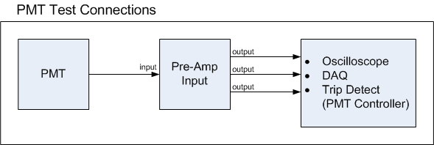

1. Make sure the PMT Controller is untripped before beginning the testing. Red LED should be off.
2. The LCD display should show a range from about 0 – 0.9V when the potentiometer is adjusted.
   1. This sets the gain for the PMT output pulse
3. Typically will not see anything on the oscilloscope with the gain less than 0.5V. Make sure the PMT pulse can be seen in the oscilloscope
4. Test trip by lowering the gain and blocking light from the PMT with your hand. Trip level should correspond with the trip voltage you set in the system setup section.